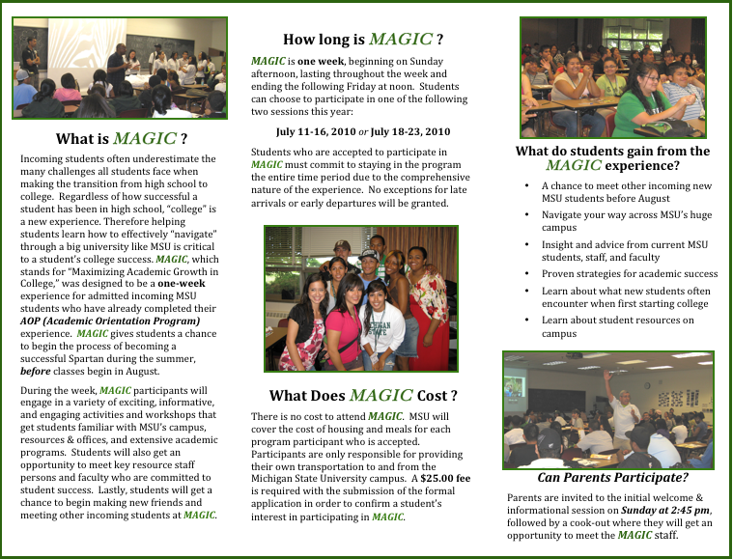


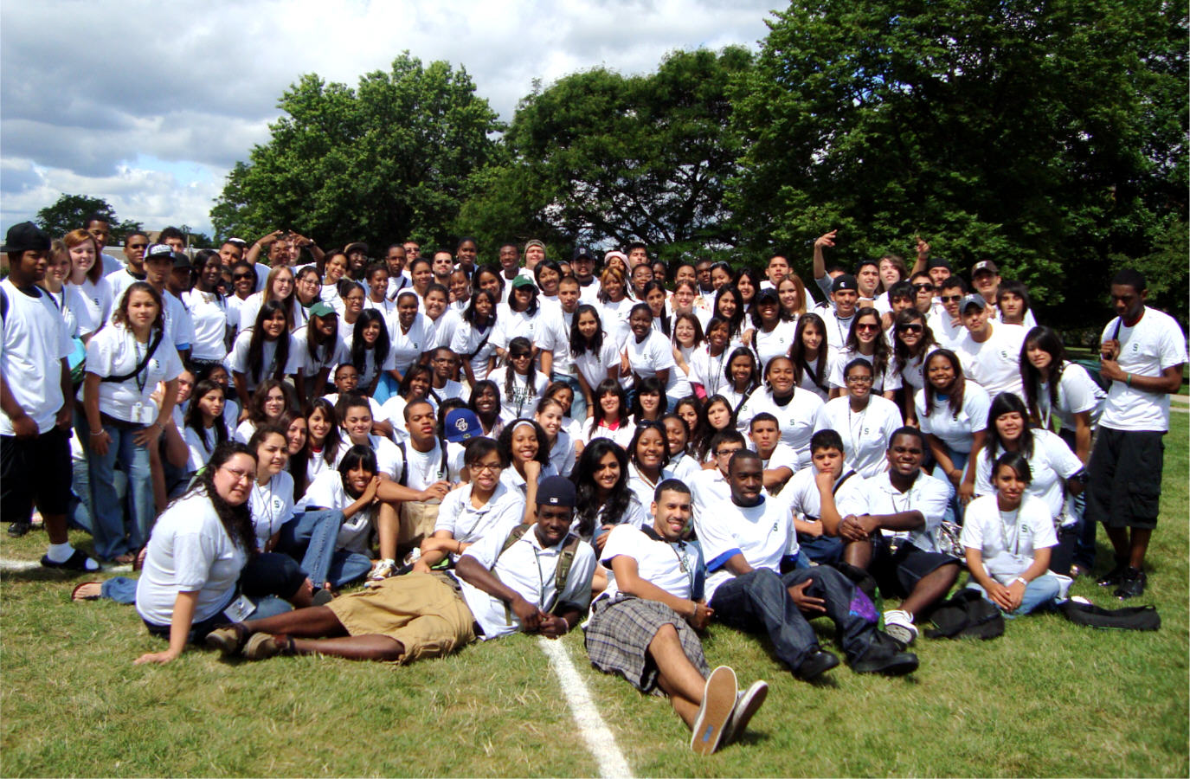
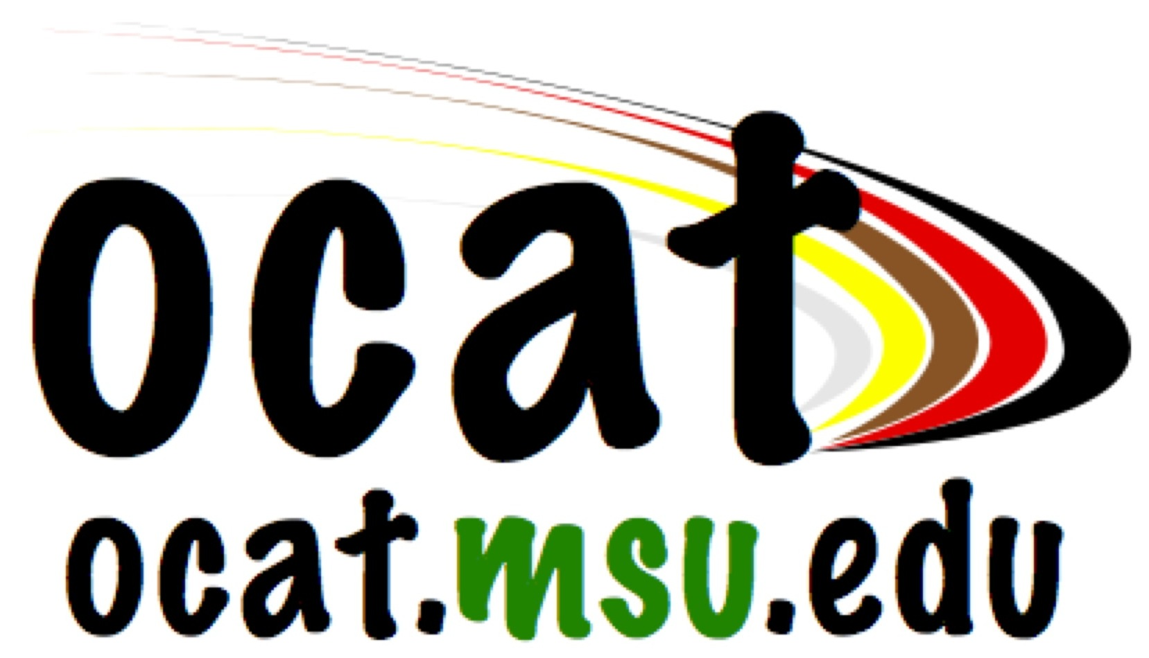
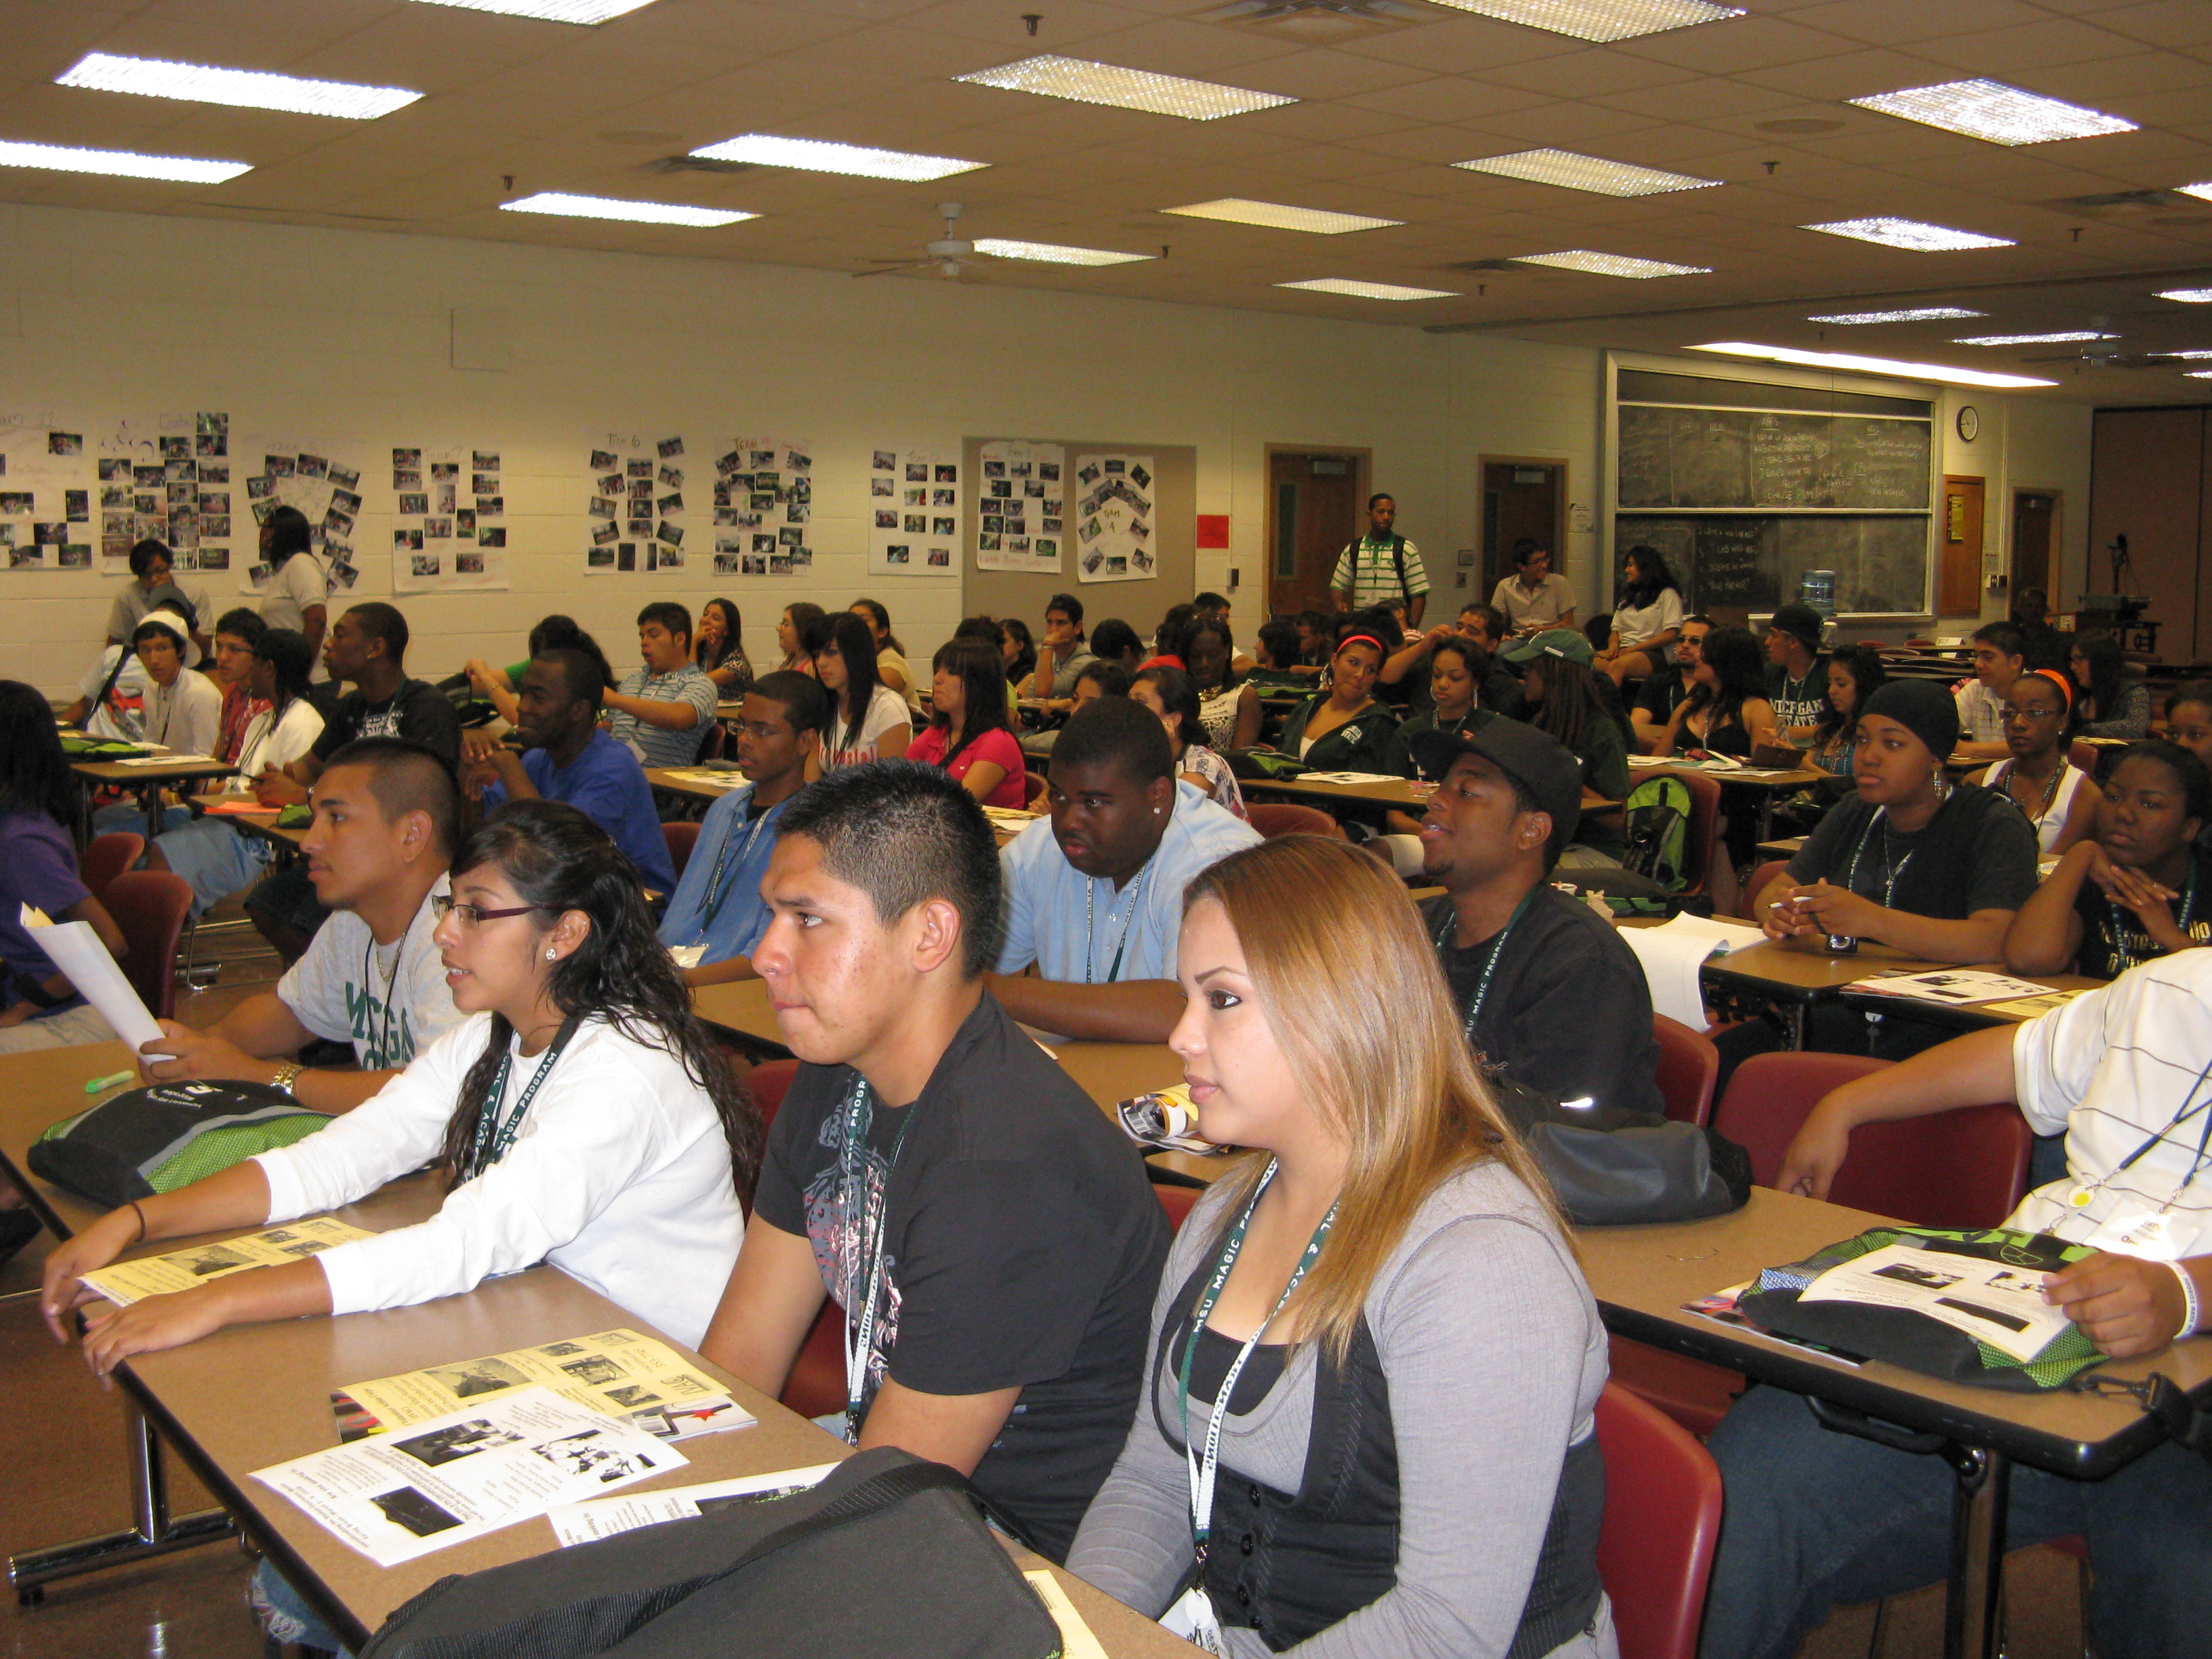
M A G I C
M.A.G.I.C.
MAGIC Interest Form

There are a limited number of students who will be able to participate in this program. Once this form is received, you will be sent a formal application for MAGIC.

I am interested in attending MAGIC during the week of (select one):

 July 11-16, 2010
 July 18-23, 2010

Please WRITE legibly.

Name: ________________________________

Address: ________________________________

City: ________________________________

State, Zip: ________________________________

Phone: ________________________________

MSU PID: ________________________________

AOP Date: ________________________________

Gender:  Male  Female

Race:

__ African American __ White

__ Asian/ Pacific American __ Arab American

__ Chicano/Latino __ Other:

__ Native American ___________________

For more information call: 517-353-7745

MAGIC Program
Office of Cultural & Academic Transitions
Michigan State University
339 Student Services Building
East Lansing, MI 48824
www.ocat.msu.edu

Accommodations for persons with disabilities are
available upon request
Maximizing Academic
Growth in College
Office of Cultural & Academic Transitions

339 Student Services Building
East Lansing, Michigan 48824
517-353-7745 / www.ocat.msu.edu

